Trieste, 9-11th July 2019
The Holocaust as a Starting Point 2
The Holocaust as a starting point

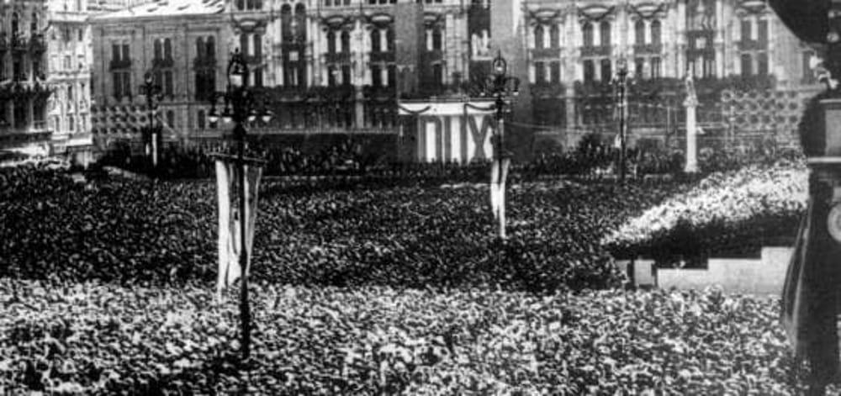



Couverture : Mémorial de la Shoah, Paris / Crédit : Mémorial de la Shoah

Proclamation of the racial laws


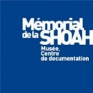



Venue University of Trieste, University of Trieste- Androna Campo Marzio 10

Participants 45 Croatian, Slovenian and Italian teachers and 3 representatives from the local agencies

Languages English
Coordinators: Loranda Miletic, Croatian Education and Teacher training Agency
Vojko Kunaver, Slovenian educational Agency
Giuseppe Pierro, Italian Ministry of Education
Tullia Catalan, university of Trieste
Bruno Boyer, Laura Fontana Mémorial de la Shoah
Moderators Bruno Boyer, Mémorial de la Shoah
Tulia Catalan, university of Trieste

Tuesday, July 9th
9.30am |  | Opening
10.00 am |  | Ice-breaking activity
10.15 am |  | Reports from the former trainees
10.45am |  | Coffee Break
11.00 am |  | Pedagogical Workshops  1-Anti-Semitism and social networks  Fabrice Teicher, Mémorial de la Shoah  2-Border and identity 1946 -1947  Kaja Sirok, Slovenian historical Museum
12.45 pm |  | Lunch
2.00 am |  | History of Anti-Semitism  Joel Kotek, free university of Brussels
3.30 pm |  | Coffe break
3.50pm |  | Changing borders and identity : 1918-1923  Borut Klabjan  (TBC)
Wednesday, 10th July
9.00 am |  | Pedagogical workshops  1-Conspiracy theory: how to challenge?  Fabrice Teicher, Mémorial de la Shoah  2- History images, image history  Ophir Levy, Mémorial de la Shoah
10.30 am |  | Coffe break
10.45 |  | The Collaboration in Europe during the Nazi rule  Tal Bruttmann, EHESS
1.00pm |  | Lunch
2.30 pm |  | The German occupation of Italy and the Adriatic Coastland  René Moehrle, University of Trier
4.00 pm |  | Coffe break
4.15 pm |  | The Persecutions against the Jews (NDH, Italian occupied zones and OZAK)  Tullia Catalan, Trieste University

Thursday 11th July University of Trieste
9.00 am |  | Risiera di San Sabba  Visit of the permanent exhibit
11.30am |  | Transitional violence in Gorizia and Trieste (1946-1954)  Frederico Tenca Montini, University of Teramo
1.00pm |  | Lunch
2.00 pm |  | The Situation in the region of Trieste at the Aftermath of WWII  Pr Pupo (TBC)
3.30 pm |  | Coffee Break
3.45 pm |  | Pedagogical Workshops  - IHA Guidelines; teaching the Holocaust  Loranda Miletic  - To be specified
5.45 |  | Conclusion

